A Mini Project with Seminar On

**Skin Lesion Detection using CNN and RNN**

Submitted in partial fulfillment of the requirements for the award of the

**Bachelor of Technology**

In

**Department of Computer Science and Engineering** **(Data Science)**

By

|  |  |
| --- | --- |
| **Varun Racha** | **20241A6746** |
| **Sreeshwan Jageer** | **20241A6752** |
| **K Arun Kumar** | **21245A6703** |
| **Ch Dheeraj Kumar** | **20241A6712** |

Under the Esteemed guidance of

**Dr. R. P. Ram Kumar**

**Professor**

**Department of Computer Science and Engineering (Data Science)**

**GOKARAJU RANGARAJU INSTITUTE OF ENGINEERING AND TECHNOLOGY**

**(Approved by AICTE, Autonomous under JNTUH, Hyderabad) Bachupally, Kukatpally, Hyderabad-500090**



**GOKARAJU RANGARAJU INSTITUTE OF ENGINEERING AND TECHNOLOGY**

**(Autonomous) Hyderabad-500090**

**CERTIFICATE**

This is to certify that the mini project entitled “**Skin Lesion Detection using CNN and RNN**” is submitted by **Varun Racha (20241A6746), Sreeshwan Jageer (20241A6752), K Arun Kumar (21245A6703) and CH Dheeraj Kumar (20241A6712)** in partial fulfillment of the award of degree in **BACHELOR OF TECHNOLOGY** in Computer Science and Engineering (Data Science) during the Academic Year 2023-2024.

|  |  |
| --- | --- |
| **Internal Guide** | **Head of the Department** |
| **Dr. R. P. RAM KUMAR** | **Dr. G. KARUNA** |
| **External Examiner** | |

**ACKNOWLEDGEMENT**

There are many people who helped us, directly and indirectly, to complete our project successfully. We would like to take this opportunity to thank one and all. First, we would like to express our deep gratitude towards our internal guide **Dr. R. P. RAM KUMAR, Professor,** Department of Computer Science and Engineering (Data Science), for his support in the completion of our dissertation. We wish to express our sincere thanks to **Dr. G. KARUNA,** Head of the Department**,** and to our Principal **Dr. J. PRAVEEN,** for providing the facilities to complete the dissertation. We would like to thank all our faculty and friends for their help and constructive criticism during the project period. Finally, we are very much indebted to our parents for their moral support and encouragement to achieve goals.

**Varun Racha (20241A6746)**

**Sreeshwan Jageer (20241A6752)**

**K Arun Kumar (21245A6703)**

**CH Dheeraj Kumar (20241A6712)**

**DECLARATION**

We hereby declare that the mini project titled **“Skin Lesion Detection using CNN and RNN”** is the work done during the period from **17th January 2023 to 12th June 2023** and is submitted in the partial fulfillment of the requirements for the award of the degree of Bachelor of Technology in Computer Science and Engineering (Data Science) from Gokaraju Rangaraju Institute of Engineering and Technology (Autonomous under Jawaharlal Nehru Technology University, Hyderabad). The results embodied in this project have not been submitted to any other University or Institution for the award of any degree or diploma.

**Varun Racha (20241A6746)**

**Sreeshwan Jageer (20241A6752)**

**K Arun Kumar (21245A6703)**

**CH Dheeraj Kumar (20241A6712)**

**ABSTRACT**

A prevalent form of cancer that affects millions of individuals globally is skin cancer. The visual examination of skin lesions, however, is a challenging and time-consuming procedure that calls for the knowledge of dermatologists. The proposed effort intends to create an accurate and effective system for detecting skin lesions that can help dermatologists identify and treat a variety of skin conditions. To extract features from skin lesion photos, the method uses a pre-trained Convolutional Neural Network (CNN). These characteristics are then fed into a Recurrent Neural Network (RNN) for temporal modelling. The early diagnosis of numerous skin illnesses depends greatly on the detection of skin lesions. Deep learning models, particularly CNNs, have demonstrated impressive performance in the computer-aided diagnosis of skin lesions in recent years. CNNs might not be able to fully capture the sequential dependencies found in the spatial information of skin lesion images on their own, though. Using the HAM 10000 dataset, this work suggests a hybrid CNN and RNN model for skin lesion detection. A sizable collection of skin lesion photos divided into seven groups may be found in the HAM 10000 dataset. The hybrid model combines the advantages of RNNs for temporal dependency detection and CNNs for feature extraction from images. For the purpose of extracting spatial characteristics from the input images, the proposed model consists of several convolutional layers. To capture the sequential information, these features are subsequently reshaped and supplied into an RNN layer, specifically an LSTM layer. The model is then added dense layers for categorization. The hybrid model seeks to increase the precision of skin lesion identification by combining CNNs and RNNs.

**LIST OF FIGURES**

|  |  |  |  |
| --- | --- | --- | --- |
| **Figure No.** | **Figure Name** | | **Page No.** |
| **1.1** | Classification using CNN | | **3** |
| **1.2** | Architecture of RNN | | **5** |
| **1.3** | Architecture Diagram | | **9** |
| **3.1** | Module Diagram | | **20** |
| **3.2** | Connectivity diagram | | **22** |
| **3.3** | Resizing of Skin Image | | **23** |
| **3.4** | Data Augmentation of Skin Image | | **24** |
| **3.5**  **4.1** | Use Case Diagram  Different types of skin lesions | | **29**  **32** |
| **4.2** | Sample Pictures of HAM10000 | | **33** |
| **4.3** | Graph of Skin lesion images based on count | | **34** |
| **4.4** | Preprocessing Of skin lesion Image | | **35** |
| **4.5**  **4.5** | Result image of melanoma  Result image of melanocytic nevus | | **36**  **36** |
|  | |

**LIST OF TABLES**

|  |  |  |
| --- | --- | --- |
| **Table No.** | **Table Name** | **Page No.** |
|  |  |  |
| 1 | Significance of Existing Approaches and  limitations | **16** |
|  |  |  |
|  |  |  |
|  |  |  |
|  |  |  |
|  |  |  |
|  |  |  |
|  |  |  |
|  |  |  |
|  |  |  |
|  |  |  |
|  |  |  |
|  |  |  |
|  |  |  |
|  |  |  |
|  |  |  |
|  |  |  |
|  |  |  |
|  |  |  |
|  |  |  |

**TABLE OF CONTENTS**

|  |  |  |
| --- | --- | --- |
| **Chapter No.** | **Chapter Name** | **Page No.** |
|  |  |  |
|  | Certificate | i |
|  | Acknowledgment | ii |
|  | Declaration  Abstract | iii  iv |
|  | List of Figures | v |
|  | List of Tables | vi |
|  |
|  |  |  |
| **1** | **Introduction** | **1** |
|  | 1.1 Introduction to the project work | 1 |
|  | 1.2 Objectives of the Project  1.3 Methodology adopted | 7  7 |
|  | 1.4 Architecture Diagram  1.5 Organization of the Report | 9  9 |
| **2** | **Literature Survey** | **11** |
|  | 2.1 Existing Approaches | 11 |
| **3** | **Proposed Method** | **19** |
|  | 3.1 Problem Statement and Objectives  3.1.1 Problem Statement  3.1.2 Objectives Of The Project  3.2 Architecture Diagram  3.3 Connectivity diagram  3.4 Software and Hardware Requirements  3.5 Modules and Description  3.6 Requirements Engineering  3.7 Analysis and Design through UML  3.7.1 USE Case Diagram | 19  19  19  19  20  22  23  27  28  28 |
| **4** | **Results and Discussions** | **31** |
|  | 4.1 Dataset details | 31 |
|  | 4.2 Significance of Experimental Results | 34 |
|  | 4.3 Significance of the proposed methods | 38 |
| **5** | **Conclusion and Future Enhancements** | **40** |
| **6** | 5.1 Conclusion  **Appendices**  6.1.1 Import libraries  6.1.2 Data Augmentation  6.1.3 CNN Model  6.1.4 RNN Model | 40  **43**  43  43  45  46 |
|  |  |  |
|  | **References** | **49** |
|  |  |  |
|  |  |  |

**CHAPTER 1**

**INTRODUCTION**

The rising incidence of damaging UV rays in the environment, skin lesion cancer is a growing global health concern. The researchers found that an extra 10% ozone layer loss will increase the number of occurrences of skin lesion cancer by 300,000 non-melanoma and 4,500 melanoma per year. A skin lesion is an unnatural growth, bump, spot, or patch that appears on the skin. Skin lesions come in a wide variety of forms, from benign to malignant growth. Sun exposure, infections, genetics, and autoimmune diseases are a few common contributors to skin lesions. It is crucial to protect the skin from UV damage by donning protective clothes, applying sunscreen, and avoiding prolonged sun exposure during peak hours in order to prevent skin lesions. Additionally, it's critical to practice excellent hygiene, refrain from lending or borrowing others' personal products like towels or razors, and take fast action to cure any skin diseases or infections to stop them from getting worse. Regular skin checks and seeking prompt medical attention for any new or changing skin lesions can also help detect skin cancer early when it is most treatable. Skin lesions can also be caused by factors such as aging, hormonal changes, certain medications, and underlying medical conditions. For example, acne is a common skin condition that can lead to the formation of skin lesions, such as pimples, blackheads, and cysts. Other medical conditions that can cause skin lesions include psoriasis, eczema, and rosacea. In order to construct a model for skin lesion identification, we apply machine learning algorithms.

As a subset of artificial intelligence (AI), machine learning (ML) focuses on creating statistical models and algorithms that allow computers to automatically improve their performance by learning from data rather than being explicitly or manually programmed. In machine learning, a huge dataset is used to train the computer, which then uses the training data to find patterns and relationships that can be applied to fresh data to produce predictions or choices. Machine learning comes in three flavors reinforcement learning, unsupervised learning, and supervised learning.

The model is trained using supervised learning utilizing labelled data, where each data point is connected to a label or target variable. Learning a mapping function that can correctly anticipate the target variable from new data is the objective. Without any specified labels, unsupervised learning entails training the model on unlabeled data. Finding patterns in the data that can help us understand it better is the aim. Through interaction with the environment and feedback, a computer learns to make judgements through reinforcement learning. Machine learning is utilized in many different applications, including fraud detection, recommendation systems, speech recognition, natural language processing, picture recognition, and image classification.

Let us understand in detail the techniques we use in our project. They are CNN and RNN.

CNN is a neural network method that's mainly used for categorizing, analyzing, and recognizing images and videos. Edge detection or feature extraction are only two examples of the various operations performed by each layer of interconnected nodes that makes up a CNN. The main idea behind CNNs is to apply convolutional filters to the input image, which helps to extract important details, patterns, and structures from the image. The final output, which resembles a classification label, is produced by feeding these features into a sequence of neural network layers for additional analysis and processing. CNNs are widely used in a variety of applications, including object identification, facial recognition, self-driving automobiles, and medical image analysis. They are particularly useful for problems involving challenging and huge datasets, where traditional machine learning techniques might not be effective. In general, CNNs have revolutionized the domains of computer vision and image analysis as well as created new opportunities for applying deep learning to a range of practical problems. By studying biological processes, CNN was inspired. In these, a network's connectivity structure reflects how the visual brain of animals is set up. The receptive field describes the response of a single cortical neuron within a defined area of the visual field. Different neurons' receptive areas partially overlap one another to fill the whole visual field. Convolutional, Pooling, and Fully-Connected neural layers are used in three stages by CNN to form its structures.

**Convolution Layer:** In CNN, a convolutional layer serves as the primary layer. The output layer's result is generated from the input layer in this layer by filtering under certain circumstances. The neurons that make up this layer are shaped like cubical blocks.

**Max-pooling layer:** Following each convolution layer, the pooling layer performs the subsequent action. To reduce the size of the neurons, these layers are used. These are tiny rectangular grids that take a little chunk of the convolutional layer and filter it to provide an outcome from that block. The most widely utilized layer, max pooling, retrieves the block's maximum pixel.

**Fully Connected Layers:** A CNN's final layer, which is fully connected, is created by the attachment of all earlier neurons. Due to its complete connectivity, much like in an artificial neural network, it lowers the spatial information. It is made up of neurons, starting with input neurons and ending with output neurons.

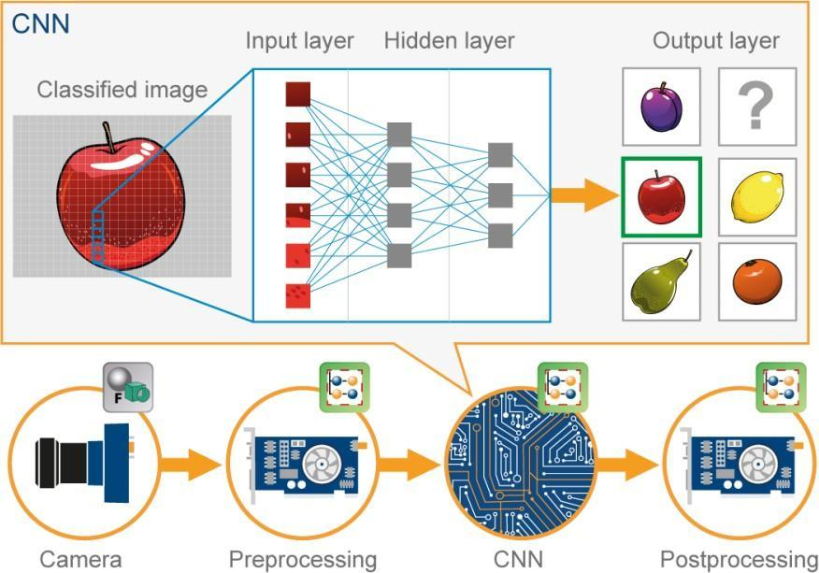

**Figure 1.1 Classification using CNN (Courtesy: Source [1])**

This image illustrates the process of using a CNN to classify an input image. The journey begins with capturing the image using a camera, which serves as the initial input. The image may undergo preprocessing steps to enhance its quality, such as resizing, normalization, or noise reduction. Once the preprocessed image is fed into the input layers of the CNN, it passes through a series of hidden layers. These hidden layers consist of convolutional layers, which extract various visual features and patterns from the image using filters and convolutions. Non-linear activation functions are applied to introduce non-linearity and capture complex relationships between the features. The output of the hidden layers is then fed into the output layers of the CNN. The output layers typically consist of fully connected layers, which learn high-level representations and classify the image into different classes or categories. Each neuron in the output layer corresponds to a specific class, and the network assigns probabilities or confidence scores to each class based on the extracted features. Finally, the post processing stage may involve further analysis or refinement of the classification results. This can include thresholding, filtering, or additional processing techniques to improve the accuracy or interpretability of the final classification. Overall, this image demonstrates the sequential flow of an image through the different stages of a CNN, from input layers to hidden layers and output layers, highlighting the powerful capabilities of CNNs in image classification tasks.

RNN is primarily used for processing sequential data, such as text, speech, and time series data. Unlike traditional feedforward neural networks, which process data in a single pass, RNNs have loops that allow information to persist over time and be processed in a recurrent manner. The basic idea behind RNNs is to use feedback connections to allow information to flow from one time step to the next. This enables the network to use previous inputs to inform its processing of current inputs, and to maintain an internal state that captures information about the input sequence seen so far. RNNs can process input sequences of arbitrary length and produce output sequences of variable length, making them particularly well-suited for problems involving sequences of variable length. This qualifies them for use in time series prediction, natural language processing, and speech recognition. The "vanishing gradient" issue, which can make it challenging to learn long-term relationships in the input sequence, can affect RNNs, though. Several RNN variants have been created to solve this problem, including Long Short-Term Memory (LSTM) and Gated Recurrent Unit (GRU), which have been demonstrated to be successful in learning long-term relationships in sequential data. RNNs have generally been a popular deep-learning technology that has allowed for substantial advancements in a variety of fields.

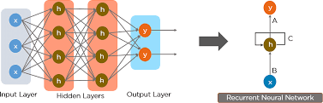

**Figure 1.2 Architecture of RNN (Courtesy: Source [2])**

The above image illustrates the utilization of an RNN for processing sequential data, such as text or time series data. In this context, the input to the RNN is a sequence of data points rather than an image. The sequence of data, represented as a series of inputs, is passed into the input layer of the RNN. Each data point in the sequence is sequentially processed by the RNN's hidden layers, which are composed of recurrent units. These recurrent units maintain an internal state that allows them to capture the temporal dependencies and patterns present in the sequence. As the RNN processes each input in the sequence, the hidden layers update their internal state based on the current input and the information stored from previous inputs. This recurrent nature enables the RNN to capture long-term dependencies and contextual information within the sequence. The output of the last hidden state in the RNN is then passed through the output layer, which produces the final prediction or classification result. This output layer can be a fully connected layer with appropriate activation functions, depending on the specific task. Like CNN, the RNN can undergo post processing steps to refine or interpret the results. This may involve applying additional calculations or analysis on the RNN's output, such as thresholding, smoothing, or further processing to extract meaningful information from the predicted sequence. In summary, the image depicts the process of utilizing an RNN to process sequential data. It showcases the flow of the sequence through the input layer, the recurrent hidden layers, and finally the output layer, emphasizing the RNN's ability to capture temporal dependencies and make predictions based on the sequential nature of the data.

The dataset used for the project is HAM10000, the dataset contains 7 different lesions images. There is a Total of 10015 images of Skin Lesion images. Skin Lesions labels are:

Melanocytic nevi are benign neoplasms of melanocytes and appear in a myriad of variants, which all are included in our series. The variants may differ significantly from a dermoscopic point of view. HAM10000 data set contains 6705 images of NV Lesion. Melanoma is a malignant neoplasm derived from melanocytes that may appear in different variants. If excised in an early stage it can be cured by simple surgical excision. Melanomas can be invasive or non-invasive (in situ). We included all variants of melanoma including melanoma in situ, but did exclude non-pigmented, subungual, ocular, or mucosal melanoma. Ham 10000 data set contains 1113 images of MEL Lesion.

Seborrheic keratoses, also known as "senile warts," solar lentigo, which is a flat variant of seborrheic keratosis, and lichen-planus like keratoses (LPLK), which is a seborrheic keratosis or a solar lentigo with inflammation and regression, are all considered to be benign keratoses. The three categories may have diverse dermoscopic appearances, but we combined them since their biological characteristics are comparable and their histopathological reports frequently utilize the same general word. Because they can exhibit morphologic characteristics that mimic melanoma and are frequently biopsied or removed for diagnostic purposes, lichen planus-like keratoses are particularly difficult to treat from a dermoscopic perspective. A BKL lesion is depicted in 1099 photos in the Ham 10000 data set. A typical epithelial skin cancer variety called basal cell carcinoma seldom metastasizes but, if left untreated, spreads destructively. This set has all of its various morphologic manifestations (flat, nodular, pigmented, and cystic, etc.).In the Ham 10000 data collection, 514 pictures of lesions can be found. The two most prevalent non-invasive forms of carcinoma of squamous cells that can be treated locally and without surgery are actinic keratoses (also known as Solar Keratoses) and intraepithelial carcinoma (also known as Bowen's disease). Some authors do not consider them true carcinomas but rather squamous cell carcinoma precursors. The possibility of these lesions developing into invasive squamous cell carcinoma, which is typically non-pigmented, is acknowledged, nevertheless. Both neoplasms frequently exhibit surface scaling and lack color. On the face, actinic keratoses are more frequent, but Bowen's disease is more prevalent elsewhere on the body. Except in cases of Bowen's disease, which is brought on by human papilloma virus infection rather than UV exposure, both types of UV light-induced damage to the surrounding skin are typically characterized by severe damage. Actinic keratoses and Bowen's disease both have pigmented forms. Both are a part of this collection. AIKEC Lesion is depicted in 327 photos in the Ham 10000 data collection. The dataset includes a variety of vascular skin lesions, including cherry angiomas, angiokeratomas, and pyogenic granulomas. This category also includes hemorrhage. VASC Lesion is depicted in 142 photographs in the Ham 10000 data collection. A benign skin lesion known as a dermatofibroma is thought to be either a benign growth or an inflammatory response to minor trauma. It is frequently brown and dermoscopically has a core zone of fibrosis. 115 pictures of the DF Lesion are included in the Ham 10000 data collection. From a dermatoscopic perspective, these variations may all be very different. Finding patterns in the data that can help us understand it better is the aim.

* 1. **OBJECTIVES OF THE PROJECT**
     + Implementing skin lesion detection to categorize skin lesion photos is the major goal of skin lesion detection using CNN and RNN.
     + This can be achieved by designing and developing a better algorithm using CNN and RNN and high accuracy to determine correct skin lesions and early detection
     + To learn the spatial and temporal features of skin lesion images, CNN is integrated with RNN for optimizing the CNNs performance.
     + The objective of the project is to develop a skin lesion detection system using a hybrid CNN and RNN model. The system aims to accurately classify and detect various types of skin lesions from input images.
  2. **METHODOLOGY**

This section will demonstrate the conceptual and operational stages of our application. The user logs into the website where the platform is located, registers, and casts their votes in a secure and open manner. The procedure is described below.

1. **Input**

In this stage, the image is taken from the user, and the image is sent to the pre-processing user needs to insert the valid skin image.

1. **Pre-Processing Stage**

In this stage, the user-inserted image is taken and the image is pre-processed this includes three steps

* + Normalizing the images
  + Resizing images to a consistent size
  + Applying data augmentation techniques

1. **Feature Extraction**

The spatial characteristics and temporal features are extracted at this stage.

* + - To extract characteristics from the photos, CNN is employed. This entails extracting high-level features that may be applied for classification by running the preprocessed pictures through a number of Convolutional and pooling layers.
    - RNN is used to process the feature vectors in order. In order to capture the temporal connections between the features, this entails running the feature vectors through a number of recurrent layers.

1. **Training and Evaluation**

The training stage involves

* Forward propagation: The input data is passed through the layers of the model, and the output is calculated.
* Backward propagation: If any error occurs. The error is calculated and propagated back through the layers of the model, and the weights are adjusted accordingly.
* Optimization: The weights of the model are updated using an optimization algorithm such as SGD or Adam.

1. **Output Classification**

Once the model has been trained and evaluated, it can be deployed to a production environment to classify skin lesions in new images

**1.4 ARCHITECTURE DIAGRAM**

The input image is passed through numerous convolutional layers in the proposed architecture, and then pooling layers are added to minimize the dimensionality of the feature maps. To create a feature vector, the obtained feature maps are flattened and run through a fully linked layer. A RNN-based model, such as a Long Short-Term Memory (LSTM) network, is then given the feature vector. The temporal associations between the feature vectors are captured by the LSTM network when given a sequence of feature vectors as input. A fully connected layer is then applied to the LSTM network output to get the final prediction. Convolutional and recurrent layers are combined in the suggested architecture for skin lesion identification utilizing CNNs and RNNs, along with additional strategies to enhance performance and avoid overfitting.

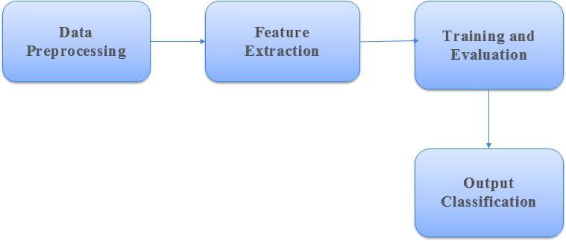

**Figure 1.3 Architecture Diagram**

**1.5 ORGANIZATION OF THE REPORT**

This report consists of the overview of all topics discussed in this entire report in a brief and concise manner with the sequence of topics presented.

**Introduction**

In this section, we discussed our project and the use case of our project, and how it is useful to our users. We discussed the basic working of the overall project.

**Literature Survey**

In this section, we discussed the existing approaches to solve this problem and their drawbacks and advantages. This section provides the required knowledge and momentum to carry out the project.

**Proposed Method**

The proposed method is a hybrid model combining CNN and RNN for improved performance in a specific task. It leverages the CNNs' ability to obtain spatial characteristics from images and the RNNs' capability to capture sequential dependencies in the data. The model takes an image as input, passes it through the CNN layers to extract relevant features, and then feeds these features into the RNN layers for further analysis and context modeling. This integration of CNNs and RNNs allows the model to capture both spatial and temporal information, enhancing its ability to classify or predict based on the specific task at hand.

**Results and Discussions**

The study's findings show that the suggested hybrid CNN and RNN model produced improved performance compared to previous approaches. The model demonstrated higher accuracy and better prediction capabilities in the task of skin disease detection. The combination of CNNs and RNNs allowed for effective feature extraction and sequential analysis, enabling the model to capture both spatial and temporal patterns in the data. These findings highlight the potential of hybrid CNN and RNN models in enhancing the accuracy and reliability of skin disease detection systems.

**Conclusion and Future Enhancements**

The study on skin lesion detection with CNNs and RNNs came to the conclusion that it is a potential strategy for enhancing the precision of skin lesion diagnosis. The performance of the model can be enhanced by the combination of CNNs and RNNs, which can capture both spatial and temporal characteristics in the images. Nevertheless, by collecting the temporal changes in the skin lesion images, RNN-based models can be used to further increase the accuracy. Despite the encouraging results, there are still issues to be resolved in the field of skin lesion detection utilizing CNNs and RNNs.

**CHAPTER 2**

**LITERATURE SURVEY**

## 2.1 Existing Approaches

Shukla and his team suggested a. A federated machine learning technique has made it possible for medical professionals [4], especially dermatologists, to reliably identify the kind and severity of skin problems. The architecture can identify the type of disease and continuously increase the accuracy of its diagnosis thanks to its intelligent local edges (dermoscopy) and global point (server). The International Skin Imaging Collaboration (ISIC) 2019 dataset (dermoscopy pictures) was used to test and validate the model and show its accuracy and adaptability. To sum up, a federated machine learning-based (hardware) dermoscopy equipment has been developed to help dermatologists diagnose skin tumors. This device offers an intelligent dermoscopy device that can increase accuracy and shorten analysis times.

Syed and his team suggested a computational method that takes into account the many various properties of the processed photographs when analyzing, processing, and relegating image data [5]. An image's characteristics are extracted using sophisticated methods like CNN, and the softmax classifier algorithm is then used to categorize the image. Diagnostic report findings are output, which is quicker and more accurate than any prior techniques. Finally, the program will offer an automated method that makes use of image segmentation and classification procedures, making it a more effective and dependable approach for diagnosing dermatological illnesses.

Anika and his team suggested a prototype that recognizes several forms of skin illnesses based on feature extraction and uses an image processing technique, specifically a color segmentation technique with an SVM classifier [6]. According to the approach, it can accurately identify eight different skin conditions 94.79% of the time. The design makes the supposition that a user will take a photo of the infected person using a camera, smartphone, or hand-controlling device. It is quick, easy to use, and compatible with many programmable devices, including desktop computers, Android phones, tablets, and iOS devices.

RishuGarg and his team suggested a Process for Effectively Detecting and Classifying Multiple Skin Cancers [7]. The method that is proposed uses CNN and algorithms for image processing to detect and categorize skin cancer using the MNIST HAM-10000 dataset of dermoscopic images. The number of images of a dermoscopy image of skin cancer is enhanced using various image enhancement techniques, and noise is removed and picture resolution is improved. The precision of the classification of the photos is further improved by a transfer learning technique, which results in an accuracy of 90.51%. A weighted mean precision of 0.88, a weighted average recall of 0.74, and a weighted f1-score of 0.77 were provided by the CNN model.

Swapna and his team suggested a framework includes three preconfigured models called Alex Net, ResNet, and InceptionV3 as well as deep learning techniques like CNN architecture [8]. For the classification of skin illnesses, a dataset of photos showing seven diseases has been collected. There are several of them, including melanoma, nevus, seborrheic keratosis, etc. A web-based application that serves as a preliminary step in the diagnosis of a condition allows a user to upload a photo of the skin area that is affected, learn the type of disease present, and receive some treatment recommendations. Technique uses deep learning techniques to determine whether the supplied skin image represents one of the seven diseases—Warts Mollusca, Systemic illness, Seborrheic Keratosis, Nevus, Bullous, Actinic Keratosis, Acne, and Rosacea—or whether it is not a skin illness. The accuracy results for CNN 90, RESNET152V2, INCEPTION V3, and ALEXNET are summarized below.

Esteva and his team suggested a deep neural network framework for skin cancer classification at the dermatologist level 79% of the time [9]. Dataset: 10,000 people versus machines the approach used is Dermoscopic images are used to classify skin cancer using deep neural networks. The result of the study showed that deep learning has the ability to effectively classify skin cancers at a level that is on par with dermatologists. The study showed that deep learning models and machine learning algorithms performed on par with human readers.

Haenssle and his team suggested a Deep Learning CNN method for recognizing dermoscopic melanoma [10]. Diagnostic performance in comparison to 58 dermatologists is the project's main focus. The photos in the dataset are from 58 different dermatologists. Techniques of The ability of deep learning to do diagnostics when it comes to identifying dermoscopic melanoma, CNN has been compared to dermatologists. The results of the study showed how well the deep learning CNN performed on several dermatologist datasets, demonstrating its ability to serve as a diagnostic tool for melanoma identification.

Tschandl and his team suggested a multinational open web-based diagnostic study. Human readers vs. machine learning techniques for classifying pigmented skin lesions [11]. The classification of pigmented skin lesions by machine learning techniques, including deep neural network models, was compared to that of human readers. The result of the study showed that deep learning models and machine learning algorithms performed on par with human readers, demonstrating their ability to serve as diagnostic tools for categorizing pigmented skin lesions.

Fujisawa and his team hypothesized that a deep learning-based, computer-aided classifier outperforms board-certified dermatologists in the identification of skin tumors using a limited sample of clinical photos [12]. The aim of the study is to investigate if a small dataset of clinical photos can be used to build an effective skin cancer classification system using deep learning technology. Deep learning-based computer classifier is the proposed framework for skin tumor diagnosis. The project's methodology relies on deep learning, and a computer-aided classifier for the identification of skin tumors was created using clinical photos and evaluated against dermatologists. Summary: The machine learning-based classifier demonstrated its promise as an efficient diagnostic tool by accurately detecting skin tumors better than board-certified dermatologists. The trained DCNN had an overall classification accuracy of 76.5 percent. The DCNN attained 96.3 percent sensitivity.

Matsunaga K and his team hypothesized that in the identification of skin tumors, a deep learning-based, computer-assisted classifier outperforms board-certified dermatologists using a limited dataset of clinical photos [13]. The project's goal is to ascertain whether deep learning technology can be used to create an effective skin cancer classification system from a small number of clinical photos. Deep learning-based computer classifier is proposed in the proposed framework for the diagnosis of skin tumors. The project's methodology relies on deep learning, and a computer-aided classifier was created utilizing clinical photos to diagnose skin tumors and be compared to dermatologists. Conclusion: In accurately diagnosing skin tumors, the deep learning-based classifier outperformed board-certified dermatologists, demonstrating its potential as a useful diagnostic tool. The trained DCNN had a 76.5% overall classification accuracy. 96.3% sensitivity was attained by the DCNN.

Akay and his team suggested a project using ensemble neural network models to categorize skin diseases [14]. This study's methodology used ensemble deep neural network models to categorize skin disorders. The use of ensemble models based on deep learning demonstrated potential in enhancing the accuracy of classification for skin disease detection, according to the final conclusion.

Celebi and his team suggested a systematic process for categorizing dermoscopic images [15]. The study on the classification of dermoscopic images made use of a variety of characteristics and machine learning methods. The suggested methodological strategy showed promise for improving the precision and dependability of automated skin lesion classification. The experiment uses skin lesions from dermoscopic photos that were gathered as a CD resource from two European university hospitals as part of the EDRA. A total of 1039 color photos with a 768 by 512 pixel resolution were included in this data set. To mimic the a priori probabilities of the clinical diagnosis, all of these photos were taken during routine clinical evaluations.

Dhungel N and his team suggested a melanoma detection using deep nueral networks in dermoscopic pictures [16]. On the ISBI 2016 Skin Lesion Research towards Melanoma Diagnosis Competition, the suggested framework is thoroughly assessed. Experimental results, which place the suggested framework first in classification and second in segmentation, show the large performance benefits of the latter. By using segmented data rather than the entire set of dermoscopic images, this architecture enables the network of classifications to extract more accurate and specialized features. This study confirms that even with little training data, very deep CNNs with efficient training mechanisms may be used to complete challenging medical image processing tasks. The recommended deep learning model's findings shown great accuracy and demonstrated promise for helping doctors identify melanoma early.

Rajpurkar and his team suggested deep learning-based pneumonia identification on chest X-rays at the level of a radiologist [17]. Chex Net, a deep learning network for pneumonia diagnosis on chest X-rays, is the project's proposed framework. The collection, made public by the NIH, consists of 112,120 frontal-view X-ray pictures of 30,805 individual patients that have been labelled with up to 14 different thoracic pathology diagnoses based on radiology reports. A deep learning model called Chex Net was created in this work to help diagnose pneumonia on chest X-rays. This led to the creation of an algorithm that can accurately identify pneumonia from frontal-view chest X-ray pictures, outperforming practicing radiologists.

Manu Goyal and team suggested a dataset augmentation for skin lesions in dermoscopic image categorization [18]. The skin lesion dataset was collected from the ISIC-2017 Challenge, a publicly available dataset. End-to-end ensemble segmentation, which combines Mask-RCNN and DeeplabV3+ with pre- and post-processing techniques, is the technology utilized to achieve the precise lesion segmentation that is displayed. The segmentation method suggested in this study fared better than other cutting-edge segmentation techniques and 2017 ISIC challenge winners in terms of well-liked segmentation performance measures.

* 1. **Summary and Drawbacks of Existing Approaches**

**Significance of Existing Approaches and Limitations**

|  |  |  |
| --- | --- | --- |
| Ref.  No. | Significance of the Approach | Limitations |
| [4] | An ensemble CNN is used as the main classifier in this model for skin diseases. Lastly, the creation of a federated machine learning-based (hardware) dermoscopic gadget to aid dermatologists in the identification of skin tumors | Limited to binary classification of melanoma and non-melanoma lesions, not considering other types of skin diseases. Reliance on a single deep neural network architecture, which may not generalize well to different datasets or skin conditions.  Lack of interpretability, making it challenging to understand the reasoning behind the model's predictions. |
| [5] | Using machine learning classification, an image-based method for identifying and classifying skin issues produces diagnostic report results that are both more accurate and quicker than any previous methods. | Reliance on a single deep neural network architecture, which may not generalize well to different datasets or skin conditions. |
| [6] | Proposed prototype that recognizes several forms of skin illnesses based on feature extraction and uses image processing techniques, notably a color segment method with an SVM classifier. Thus, the method claims to have a 94.79% accuracy rate in identifying eight different skin conditions. | Lack of detailed explanations or visualizations to aid in understanding the model's decision-making process  .Focus on the segmentation task only, without considering the subsequent classification of segmented lesions. |
| [7] | The MNIST HAM-10000 dataset, which contains dermoscopic images, is used in the proposal of the system that efficiently identifies and classifies different skin cancers utilizing CNN and computational image processing algorithms. | - Limited evaluation on a single dataset makes it difficult to judge the model's efficacy across various skin conditions or datasets.  - The lack of contrast with other cutting-edge techniques makes it difficult to assess the proposed approach's relative performance. |
| [8] | A deep learning-based, computer-assisted classifier outperforms board-certified dermatologists in the detection of skin tumors using a limited dataset of clinical photos. | The supervised learning-based classifier demonstrated its promise as an efficient diagnostic tool by reliably detecting skin tumors better than board-certified dermatologists. |
| [9] | The proposed framework contains CNN architecture and three preconfigured models named Alex Net, Res Net, and InceptionV3. In conclusion, the accuracy results for CNN 90 are presented. INCEPTION V3 65.46, RESNET152V2 88.83, and ALEXNET 74.89 | - Reliance on a group of neural networks with deep connections, which may need a lot of time and computing resources for inference and training.  - very poor accuracy, inaccurate outcomes, and poor performance |
| [10] | Dermoscopic images are used to classify skin cancer using deep neural networks. The study showed that deep learning has the ability to effectively classify cancer of the skin at a level that is on par with dermatologists. | Limited evaluation on specific skin cancer types, without considering a broader range of skin diseases.  Relatively small dataset used for training and evaluation, which may limit the model's ability to generalize to larger and more diverse datasets. |

|  |  |  |
| --- | --- | --- |
| [11] | The ability of deep learning to do diagnostics When it comes to identifying dermoscopic melanoma, CNN has been compared to dermatologists. The deep learning CNN outperformed dermatologists in the trial, demonstrating its promise as a diagnostic tool for cancer diagnosis. | Due to the utilisation of combined models and multiple scales processing, there are very high computing requirements, which may restrict applications that require real-time processing. The comprehensibility of the outputs is not stated, nor is the decision-making process of the model. |
| [12] | Comparison of machine learning algorithms and human readers for classifying pigmented skin lesions, The study showed that deep learning models and other machine learning algorithms performed with human readers, demonstrating their efficiency as diagnostic tools for categorizing pigmented skin lesions. | Very low accuracy and not showing exact results and not performing well. Relatively small dataset used for training and evaluation, which may limit the model's ability to generalize to larger and more diverse datasets. |
| [13] | Deep neural network ensemble for Melanoma, nevus, and seborrhea image classification | The proposed ensemble approach achieved high accuracy in distinguishing between different skin lesion types, indicating its effectiveness in dermoscopic image classification. |

**CHAPTER 3**

**PROPOSED METHOD**

* 1. **Problem Statement & Objectives of the Project**

**3.1.1 Problem Statement**

The problem statement of the project "Skin Lesion Detection using CNN and RNN" is to offer a safe, effective method for accurately and more effectively performing skin lesion detection. This seeks to enhance early skin disease detection and diagnosis, supporting dermatologists in early decision-making. The model should be able to use CNNs to examine the spatial characteristics of the skin lesion images and extract pertinent data including texture, shape, and color. Additionally, to detect changes in lesion characteristics over time, it should extract the temporal features from consecutive images using RNNs. As a result, medical practitioners will be able to trust the model and use it successfully in clinical practice.

**3.1.2 Objectives of the Project**

* + - * The major goal of skin cancer detection utilizing CNN and RNN is to offer a quick and accurate technique to find skin lesions that can assist medical practitioners in finding skin lesions early.
      * To learn the spatial and temporal features of skin lesion images, CNN is integrated with RNN for optimizing the CNNs performance.
      * To predict multi-skin lesions like melanoma, nevi (moles), dermatofibroma, seborrheic keratosis, basal cell carcinoma, and squamous cell carcinoma.
  1. **Architecture Diagram**

The input image is passed through numerous convolutional layers in the proposed architecture, and then pooling layers are added to decrease the overall dimension of the feature maps. To create a feature vector, the obtained feature maps are flattened and run through a fully linked layer. An RNN-based approach, such as an LSTM network, is then given the feature vector. The temporal associations between the feature vectors are captured by the LSTM network when given a sequence of feature vectors as input. A fully connected layer is then applied to the LSTM network output to get the final prediction. Convolutional and recurrent layers are combined in the suggested architecture for skin lesion identification utilizing CNNs and RNNs, along with additional strategies to enhance performance and avoid overfitting.

**Feature Extraction**

* **Spatial features**
* **Temporal features**

**Preprocessing**

* + **Resizing**
  + **Data Augmentation**

**INPUT**

**Training and evaluation**

**OUTPUT**

**Figure 3.1 Module Diagram**

* 1. **Connectivity Diagram**

A skin lesion detection system's data and process flow are depicted in the connectivity diagram. It consists of the following elements: Data preprocessing is the process of preparing the input data for the feature extraction phase by cleaning, converting, and organizing it. Tasks including image resizing, normalization, noise removal, and enhancement approaches may be included. The preprocessed data is run via a feature extraction module that commonly consists of CNN and RNN, at this stage. The RNN detects sequential patterns and relationships in the data, while the CNN extracts pertinent visual elements from the input images. Training: After the features have been retrieved, the system trains the combined CNN-RNN model using the labelled data. This entails using backpropagation and gradient descent algorithms to optimize the model's parameters. The goal of the training procedure is to reduce the error between the ground truth labels and the anticipated outputs. Evaluation, Using a different set of labelled data from the training set, the system is assessed after training. Metrics including accuracy, precision, recall, and F1-score are used to evaluate the model's performance. This assessment aids in determining how well the model performs in correctly categorizing skin lesions.

The connectivity diagram demonstrates how these components are interconnected. The preprocessed data flows into the feature extraction module, which then generates feature representations. These features are used for training the hybrid CNN-RNN model, which is then evaluated to assess its performance. The diagram showcases the sequential flow of data and processes, highlighting the interdependencies between data preprocessing, feature extraction, training, and evaluation stages in the skin lesion detection system. The connectivity diagram for skin lesion detection using a combination CNN and RNN involves several key components. The input layer takes skin lesion images as input. These images are pre-processed In pre-process stage the user-inserted image is taken and the image is pre-processed this includes three steps one is Normalizing the images, resizing images to a consistent size, and Applying data augmentation techniques The preprocessed image is passed through CNN layers, which extract spatial features and patterns. The outputs from the CNN layers are then passed through pooling layers to down-sample the feature maps. Simultaneously, sequential or temporal information is associated with the lesions, such as patient history or lesion evolution. The feature vector is then fed into an RNN-based model, such as a LSTM network. In a fusion layer, the outputs generated by RNN and CNN pathways are combined with temporal and spatial information. The combined features are then supplied into output layers and fully linked layers for categorization or prediction. With the use of this combination strategy, it is possible to improve the accuracy of skin lesion identification by utilizing both spatial and temporal information.

**INPUT PICTURE**

**DATA PREPROCESSING**

**RECURRENT**

**LAYER**

Processed Image

**CONVOLUTION LAYER**

Temporal Features

Spatial Features

**FUSION LAYER**

**POOLING LAYER**

**OUTPUT LAYER**

**Figure 3.2 Connectivity Diagram**

* 1. **Software and Hardware Requirements**
* Google Collaboratory
* Google Drive for storing Data
* Let’s anyone use the browser to create and run arbitrary Python programmes.
* Particularly suitable for data analysis and machine learning methods

**Hardware Specifications**

* Min 4GB of Ram
* 32GB of Minimum Storage
* Should Support the web Applications
* Processor: Intel Core i3 CPU or better

**3.5 Modules and their Description**

1. **Input**

The user's image is captured at this point, and the image is then transmitted to the pre-processing stage. The user must enter a legitimate skin picture.

1. **Pre-Processing Stage**

This stage involves taking the user-inserted image and preprocessing it, which entails two processes.

* **Resizing images to a consistent size**

When working with skin lesion images, it is often necessary to resize them to a consistent size for various purposes, such as analysis, comparison, or input to machine learning algorithms. Resizing images to a uniform size ensures that they have the same dimensions, which can be beneficial for data processing and analysis. By resizing skin lesion images to a consistent size, you eliminate variations in image dimensions, making it easier to compare and analyze different images. In this step, the image is resized to the size of 300X300. This process helps the feature extraction is easy Resizing images to a uniform size ensures that they have the same dimensions

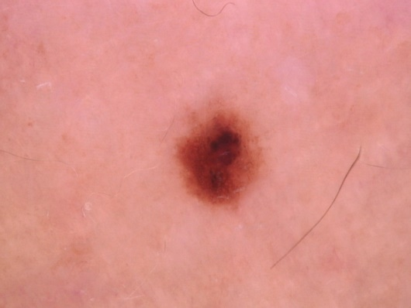 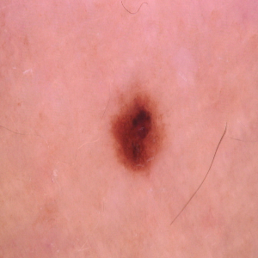

**450 x 600 300 x 300**

**Figure 3.3 Resizing of Skin Image**

* + **Applying data augmentation techniques**

By performing various alterations on the already-existing photos, a technique called data augmentation can be used to unnaturally expand the size of a dataset. It is frequently employed in computer vision and machine learning tasks, such as the interpretation of images of skin lesions. Scaling, cropping, rotation, and other regularly used techniques are only a few.

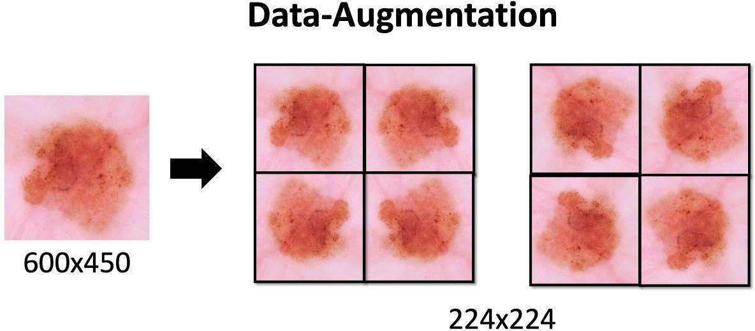

**300X300**

**Figure 3.4 Data Augmentation of skin image**

**c) Feature Extraction**

The spatial characteristics and temporal characteristics are extracted at this stage.

* For feature extraction in image-related applications, CNNs are frequently used. Multiple convolutional layers, pooling layers, and fully linked layers make up CNNs. The input image is subjected to filters by the convolutional layers, which extract regional patterns and characteristics. The feature maps' spatial dimensions are reduced by the pooling layers down sampling them. The input image is transmitted through the convolutional layers during the feature extraction process using CNNs, which convolve the image using learnt filters to detect different characteristics including edges, textures, and forms. As the depth of the network grows, each convolutional layer catches increasingly complicated characteristics. The pooling layers aid in reducing the feature maps' dimensionality while retaining crucial data. To construct a fixed-length feature vector, the output of the final layer of convolution or a fully linked layer is flattened or pooled. The learnt high-level features that were retrieved from the source image are represented by this feature vector. It may be subjected to additional levels of processing or input into a different model for purposes of regression, categorization, or additional tasks.
* RNNs are frequently employed for the extraction of features in time series, text, audio, or other sequential information types. RNNs use recurrent connections between the network units to identify temporal interdependence and patterns in sequential data. When extracting features from sequential input data using RNNs, each step is processed in accordance with a distinct time period or sequential component. The RNN unit receives the input along with the previous hidden state and outputs a new hidden state at each time step. The memory of the concealed state stores pertinent data from earlier time steps. The hidden state changes as the sequential data passes through the RNN, capturing time-based information. The last hidden state, which captures significant temporal information, is a shortened version or summary of the input sequence. This hidden state can be used for classification, prediction, or other tasks as well as being processed further by subsequent layers. It's crucial to remember that by combining both CNN and RNN architectures, a hybrid CNN-RNN model, for example, may benefit from the advantages of both methods for feature extraction. RNNs are proficient in extracting temporal and sequential patterns from photos, but CNNs excel at extracting spatial characteristics from images. The model can extract both temporal and spatial information by merging them, which enhances performance in tasks involving sequential information in an image context.

**d) Training and Evaluation**

A hybrid CNN and RNN model learns to extract pertinent features from the provided data and capture temporal connections within these features throughout the training phase. In this procedure, the model's parameters are iteratively updated depending on the estimated loss between the anticipated result with the initial reality tags.

These steps are frequently taken in the training process:

* Forward Propagation: After feeding the model with the input data, the forward propagation procedure starts. The input images are run through the CNN layers, which capture spatial data in a hybrid CNN and RNN model. The RNN layers then use the output of the CNN layers to capture temporal dependencies.
* Loss Calculation: The output of the RNN layers is compared to the ground truth labels, and the difference between the anticipated output and the real labels is determined using a loss function. Categorical cross-entropy and binary cross-entropy are frequent loss functions used in classification problems.
* Backpropagation: Using backpropagation, the model's parameters are updated using the computed loss. Using an optimization approach like stochastic gradient descent (SGD) or Adam, the gradients of the loss are computed with respect to the weights and biases of the model. This procedure seeks to reduce loss and enhance model predictions.
* Iteration: The forward propagation, loss calculation, and backpropagation steps are repeated for multiple iterations or epochs. Each iteration involves passing a batch of training data through the model and updating the parameters based on the computed gradients. This iterative process allows the model to gradually learn and improve its performance.

Upon training, the model is evaluated on a different validation set to determine how well it performed and to make any necessary improvements. The evaluation phase typically involves the following steps:

* Forward Propagation: The trained model receives the validation data, and the forward propagation procedure is used to generate the model's predictions.
* Performance Metrics Calculation: The model's performance is assessed using a variety of performance measures. Accuracy, precision, recall, F1 score, and area under the receiver operating characteristic (ROC) curve are examples of these measurements depending on the particular task.
* Analysis and Adjustments: To determine the model's advantages and disadvantages, the obtained performance metrics are examined. If the model is underperforming, adjustments can be made, such as fine-tuning hyperparameters, changing the model architecture, or collecting additional training data.
* Once the model is deemed satisfactory based on the validation results, it is tested on an unseen test set to evaluate its generalization and performance on new data. The test set provides an unbiased assessment of the model's efficiency and accuracy in real-world situations. The training and evaluation process requires careful monitoring and analysis to ensure that the model is learning effectively and producing accurate predictions. It may involve techniques such as regularization, early stopping, learning rate schedule, and model checkpointing to enhance performance and prevent overfitting.

**e) Output Classification**

After the training and evaluation of a CNN and RNN model, the final output is obtained through the classification process. The output represents the predicted class or label for a given input data point. The model can be used to categorize skin lesions in new images after it has been trained.

The model's output in the context of categorization of pictures is a probability distribution over the various classes or categories. Each class represents a particular thing or idea that the model has been trained to understand. A set of predicted probabilities for each class, showing the chance that the input belongs to each class, makes up the output in most cases. The class with the highest predicted probability is chosen as the model's prediction to arrive at the final classification. This class is regarded as the most likely or likely candidate label for the specified input data point.

A hybrid CNN and RNN model's classification and output can be utilized for a variety of tasks, including speech recognition, object detection, sentiment analysis, image recognition, and natural language processing. The model’s ability to accurately classify and assign labels to input data points is fundamental for asking informed decisions and solving complex problems in these domains.

**3.6 Requirements Engineering**

* **Functional**

**Image Input**: The System should accept input in the form of skin lesion images for analysis and detection. It should support various image formats and provide mechanisms for uploading or accessing the images.

**Classification/Prediction**: The System should include an output layer that performs the classification or prediction of skin diseases. It should provide probabilities or confidence scores for different disease classes or labels

**Accuracy:** The Accuracy of the output should be displayed to the User for the correct decision of skin lesions for Early Detection

* **Non Functional**

**Speed and Efficiency:** The system should process the input images and generate predictions in a timely manner. It should provide efficiency and avoid excessive computational time or resource consumption, allowing for real-time or near-real-time performance.

**Scalability:** The system should be able to handle heavy and time-changing workloads and accommodate a growing number of users or image data. It should scale effectively to support increased demand without performance degradation.

**Robustness:** The system should be robust against noisy or incomplete input data and handle unexpected scenarios gracefully. It should be resilient to image variations, noise, and potential errors in the input.

**Interpretability:** The system should provide insights regarding its predictions. It should be able to explain the basis for its decisions, helping clinicians and users understand the reasoning behind the detected skin disease.

**Privacy and Security**: The system should ensure the privacy and security of sensitive patient data. It should follow best practices for data protection, preventing unauthorized access or disclosure of personal health information.

**User Interface and Usability**: The system should have a user-friendly interface that allows healthcare professionals to interact with the system easily. The interface should be intuitive, providing clear instructions and feedback.

* 1. **Analysis and Design through UML**

**Use Case diagram**

Use case diagrams are a typical method of explaining a software system's key features. At its most basic level, a use case diagram is an illustration of a user's involvement with the system that demonstrates the connection between the user and the many use cases in which the user is engaged. A use case diagram, which is frequently supplemented by other types of diagrams, can be used to identify the various system users and use cases.

Use cases are nothing more than the system's functions organized into use cases. The actors are another element that is relevant to the use cases. Actors are anything that engages with the system in some way.

* **Symbols**

|  |  |
| --- | --- |
|  | In a use case diagram, an actor is represented as a stick figure. Each actor takes part in a single or more use cases. |
| Use Case | Interactions between existing systems, processes, or entities and future information systems outside of the future information systems themselves. |



**Skin lesion Detection System**

Image input

Admin

CNN and RNN

models

User

Fusion Layer

Output Result

**Figure 3.5 Use Case Diagram**

In this use case diagram:

* The "Admin User" is an actor who interacts with the system, providing input and receiving output results.
* The "Skin Lesion Detection System" represents the main system responsible for skin lesion detection.
* The "Image Input" component receives input images from the admin user.
* The "CNN and RNN Classification" component performs the classification task using a hybrid CNN and RNN model.
* The "Fusion Layer" component combines the results from the CNN and RNN to produce a final output.
* The "Output Results" component generates the final output, which includes the classification results and any additional information or visualization.
* The arrows between the components represent the flow of data or interactions.

This use case diagram demonstrates the flow of actions and components involved in the skin lesion detection system. The admin user provides input images, which are processed by the CNN and RNN components. The Fusion Layer combines the results from the CNN and RNN, and the Output Results component generates the final output. The admin user can then view and interpret the output results for further analysis or decision-making.

**CHAPTER-4**

**RESULTS AND DISCUSSIONS**

* 1. **Dataset details**

A labelled dataset of photos of skin lesions is necessary for the project's CNN and RNN models. The dataset is essential for teaching the models to identify and classify different types of skin lesions accurately. Here is a brief description of the dataset requirements and considerations for skin lesion detection

**Dataset Collection**: A diverse and comprehensive dataset of skin lesion images is essential for training CNN and RNN models. The dataset should include various types of skin lesions, such as melanoma, benign moles, seborrheic keratosis, and others. The images should capture different angles, resolutions, lighting conditions, and stages of the lesions.

**Data Annotation**: Each image in the dataset needs to be annotated with the corresponding class or label. Expert dermatologists or medical professionals typically provide these annotations. The labels can indicate the type of skin lesion (e.g., melanoma, benign)

**Data Balance:** It is important to consider the class distribution or imbalance in the dataset. If certain types of skin lesions are underrepresented, it can negatively impact the model's performance. Techniques like oversampling, under sampling, or class weighting can be employed to address class imbalance and ensure that the models learn effectively across all classes. By considering the three factors the HAM10000 Dataset is selected, The dermatological dataset HAM10000 contains clear clinical photos of skin lesions and is regularly utilized.. The dataset was created by a team of researchers from the Medical University of Vienna and consists of images obtained from the Department of Dermatology at the Medical University of Graz, Austria.

The name "HAM10000" stands for "Human against Machine with 10,000 training images, reflecting the purpose of the dataset, which is to train and evaluate machine learning algorithms for the classification of skin lesions. The dataset was created to address the need for accurate and automated diagnosis of skin cancer, as well as other common skin diseases.HAM10000 contains a total of 10,015 dermatoscopic images, captured from 7,419 unique patients. These images cover a wide range of skin lesions, including melanoma, nevi (moles), dermatofibroma, seborrheic keratosis, basal cell carcinoma, and squamous cell carcinoma. Each image is accompanied by rich metadata, including clinical information such as age, sex, anatomical location of the lesion, and whether the lesion is benign or malignant. The images in the HAM10000 dataset were captured using a variety of modern dermoscope, which are specialized devices used for the examination of skin lesions by the dermatologist.

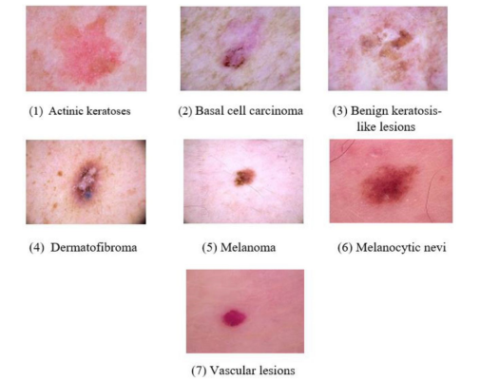

**Figure 4.1 Different types of skin lesions**

The above figure illustrates about the Different types of skin lesions present in the dataset, in the above figure seven different skin lesions are demonstrated. The images are dermoscopic images, the seven skin lesions are melanoma, melanocytic nevus, basal cell carcinoma, actinic keratosis, benign keratosis, dermatofibroma, and vascular lesion. If any of these skin lesions occurs in a human body can cause skin cancer if not recognized early.so the skin lesion detection using cnn and rnn is performed on the ham10000 data set in the view of early detection

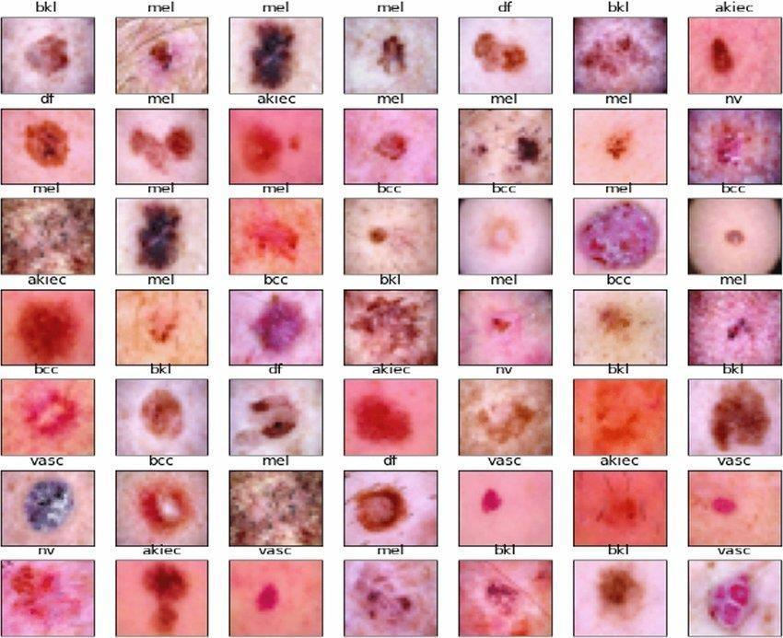

**Figure 4.2 Sample Pictures of HAM10000 dataset (Courtesy: Source [3])**

* 1. **Significance of Experimental Results**

In our study, we use computer vision and machine learning methods to automatically recognize and categorize different kinds of skin lesions, such as melanoma, nevus, or dermatofibroma. Due to its potential to assist in the early detection and diagnosis of skin malignancies, this technology has attracted substantial attention in the field of dermatology.

**Experimental Setup**

**Dataset:** Researchers typically use publicly available datasets for skin lesion detection, such as the ISIC (International Skin Imaging Collaboration) dataset. This dataset includes a significant amount of high-resolution pictures of skin lesions and the related labels.

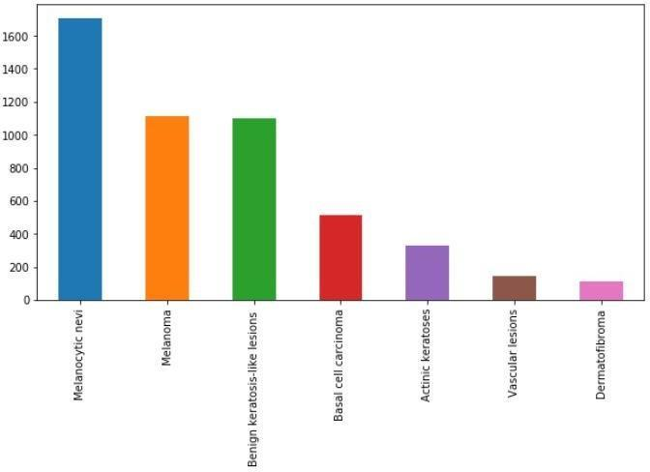

**Figure 4.3 Graph of Skin Lesion images based on count**

**Preprocessing**: Prior to training the model, the dataset is preprocessed to ensure uniformity and enhance training efficiency. Preprocessing steps may include resizing images to a standard resolution, normalizing pixel values, and augmenting the dataset by applying transformations like rotation, flipping, and scaling.

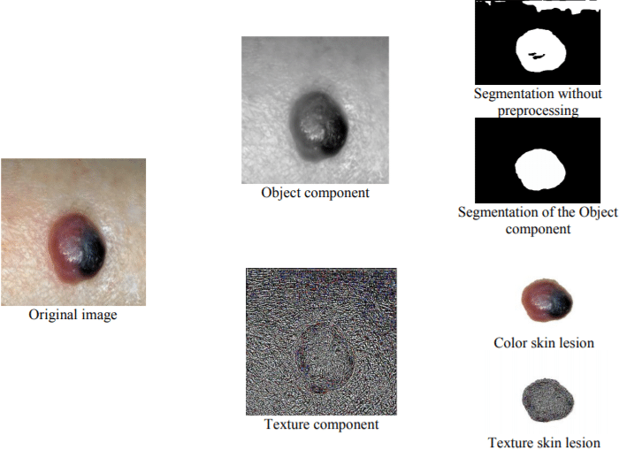

**Figure 4.4 preprocessing of skin lesion Image**

**Model Architecture:** Various deep learning models can be employed for skin lesion detection, such as CNN. A popular architecture is the Inception- ResNet-v2, which combines the Inception module with residual connections to improve feature extraction and classification.

**Training:** The dataset is divided into training and validation sets. The model is trained on the training set by optimizing a loss function, such as cross-entropy loss, using an optimization algorithm like stochastic gradient descent (SGD) The model's performance is evaluated using the validation set during training to monitor its progress.

**Results**

The following shows the classification of skin lesion image when the unknown image given as input

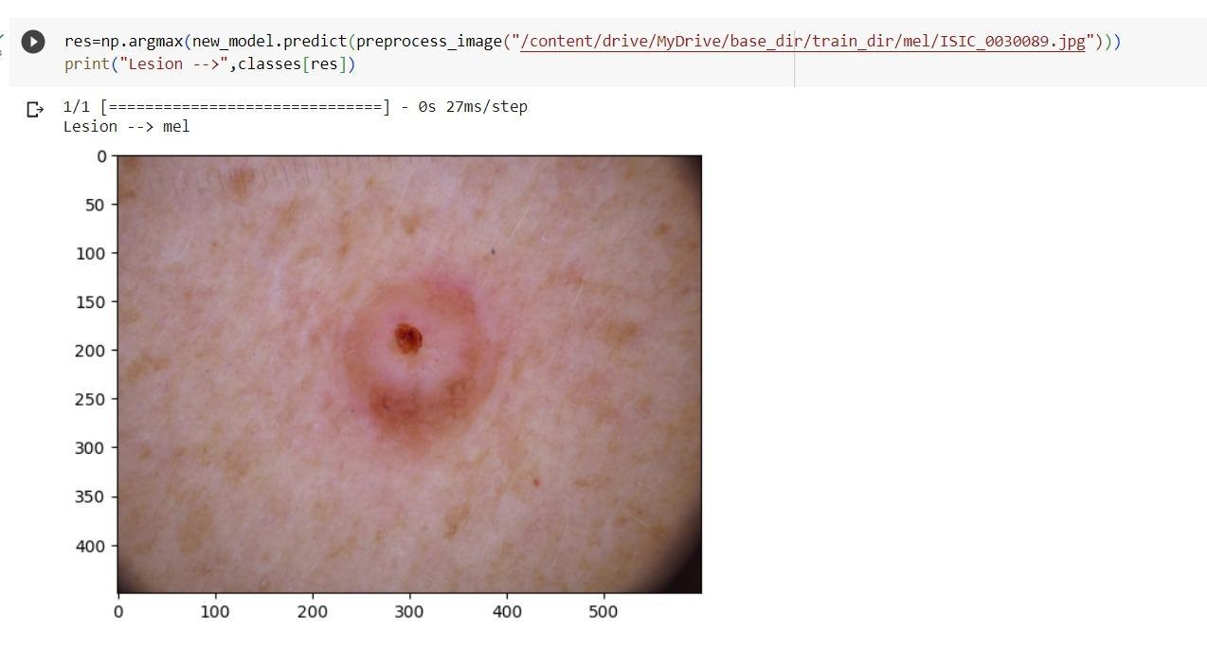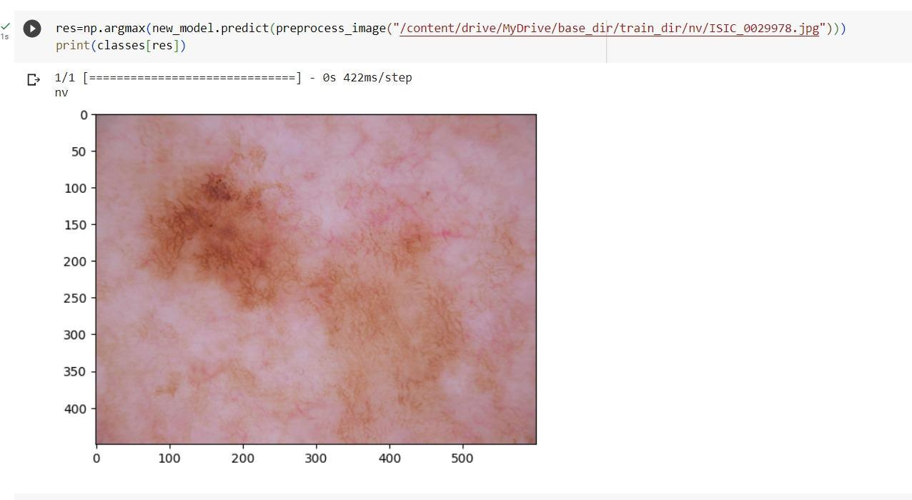

**Figure 4.5 Result image of melanoma**

**Figure 4.6 Result image of melanocytic nevus**

**Results and Evaluation**

**Performance Metrics**: Accuracy, recollection, and the F1 score are some of the performance indicators frequently used to assess the skin lesion detection model. While precision and recall concentrate on the accurate predictions, accuracy assesses how well the model as a whole performed in making predictions. A single metric called the F1-score integrates both accuracy and recall.

**Confusion Matrix:** The efficiency of a model for classification can be seen using a confusion matrix. The number of real positives, real adverse effects, false positives, and false negatives are all shown. The matrix sheds light on how well the model can categories various lesion kinds.

**Receiver Operating Characteristic (ROC) Curve**: Another assessment tool for spotting skin lesions is the ROC curve. Plotting the rate of true positives versus the rate of false positives shows how the model performs at various classification criteria. Higher numbers suggest greater performance when calculating the region under the curve of ROC (AUC), which is frequently done as a summary statistic.

**Precision-Recall Curve:** Another evaluation metric that illustrates the trade-off among precision and recall at different classification thresholds is the precision-recall curve. When dealing with skewed datasets, which are frequent in skin lesion identification, it is extremely helpful.

The provision of specific charts and pictures for a skin lesion identification test would necessitate access to a specific study or implementation, it is vital to mention. The information above outlines the typical experimental design and evaluation techniques applied in the field. In studies or articles, where visualizations customized to the particular experiment are sometimes included, researchers often present their findings.

* 1. **Significance of the Proposed Method with its Advantages**

The proposed method in our project holds significant importance in the field of dermatology and healthcare. Here are some of the key significance and advantages of such methods:

* + **Improved Accuracy:** By combining the strengths of both CNN and RNN architectures, the proposed method can capture both local spatial features (through CNN) and temporal dependencies (through RNN). As a result, the model is better able to comprehend the intricate patterns and structures contained in photos of skin lesions, increasing the accuracy of detection and categorization.
  + **Enhanced Feature Extraction:** CNNs excel at extracting meaningful features from images, while RNNs are effective in modeling sequential data. By feeding the output of the CNN into the RNN, the suggested method allows the integration of high-level spatial traits from the CNN with RNN's temporal dependencies. This enhances the representation learning process and enables the model to capture more informative features.
  + **Robustness to Variations:** Skin lesion images can exhibit variations in terms of size, shape, color, and texture. The hybrid CNN and RNN model is capable of learning robust representations that are invariant to these variations. The CNN component can capture important visual features, while the RNN component can model the temporal dependencies across different regions of the lesion, making the model more resilient to variations in lesion appearance.
  + **Handling Sequential Information:** RNNs are well-suited for processing sequential data. In the context of skin lesion detection, sequential information can be valuable, as it allows the model to consider the evolution of lesion characteristics over time. The RNN component of the proposed method enables the model to learn temporal dependencies and exploit the sequential nature of the data, leading to improved detection performance.
  + **Interpretability:** The proposed method provides interpretability by incorporating both CNN-based visual feature extraction and Sequential modelling using RNNs. This gives dermatologists and other medical practitioners insight into the model's decision-making process. In order to improve understanding and confidence in the model's predictions, the model can produce attentiveness maps or maps of saliency that highlight the areas of the image that are most important to the prediction.
  + **Scalability and Efficiency:** The hybrid CNN and RNN model can be trained and deployed efficiently on modern hardware, making it scalable to handle large datasets and real-time applications. The model can benefit from GPU acceleration for faster training and inference, allowing for quick and accurate diagnosis in clinical settings.
  + **Generalizability:** The proposed method has the potential to generalize well to unseen skin lesion images and different types of skin diseases. By leveraging both spatial and temporal information, the model can learn robust representations that are applicable across various lesion types, making it versatile and adaptable to different clinical scenarios.

In Conclusion, the proposed hybrid CNN and RNN method offers improved accuracy, enhanced feature extraction, robustness to variations, interpretability, scalability, and generalizability. These advantages make it a promising approach for skin lesion detection, with the potential to assist dermatologists in accurate diagnosis and improve patient care.

**CHAPTER 5**

**CONCLUSION AND FUTURE ENHANCEMENT**

**5.1 Conclusion**

In the discipline of dermatology, the diagnosis of skin lesions using artificial intelligence and neural network approaches has shown considerable potential. These methods have the potential to improve early detection of skin cancers, reduce diagnostic errors, and provide decision support to dermatologists. By automating the detection process, these methods offer time efficiency, scalability, and cost-effectiveness. They also have the advantage of continuous learning and improvement, adapting to evolving trends and variations in skin lesion characteristics. In this study, we created a hybrid model for categorizing photos of skin lesions that employs both CNN and RNN. To increase the precision of lesion categorization, the combination approach tries to combine the geographical data collected by the CNN and the temporal dependencies collected by the RNN. In order to extract pertinent information from the input photos, we first created a CNN architecture with numerous convolutional and pooling layers. The CNN's output was then modified to take into account the RNN's desired form for its input. For capturing the temporal associations in the retrieved features, we then added an LSTM layer. The model achieved satisfactory results, demonstrating its ability to accurately classify skin lesion images. We also visualized the confusion matrix, which provided insights into the model's performance across different lesion classes. This allowed us to identify any potential biases or areas where the model may be struggling. Throughout the training process, we implemented various techniques to enhance model performance. To broaden the training set's diversity and enhance the model's generalizability, data augmentation was used. In order to make guarantee that the input data fell within a constant range, we also used normalization techniques. Additionally, to avoid overfitting and enhance the model's generalizability, regularization strategies like dropout were used.

Overall, hybrid CNN-RNN system proved to be effective in classifying skin lesion images, combining the strengths of both CNN and RNN architectures. Further improvements could be made by exploring different model architectures, hyper parameter tuning, and incorporating additional techniques such as transfer learning. In conclusion, our hybrid CNN-RNN model offers promising results for skin lesion classification, and with further refinement and experimentation, it holds potential for real-world applications in dermatology and healthcare.

**Enhancements for Skin Lesion Detection**

Additionally to the hybrid CNN and RNN model we created for skin lesion identification, the following improvements should be taken into account to boost the model's performance and accuracy further:

* Data Augmentation: Through the use of data enrichment techniques, the training dataset can be made more diverse, which helps improve generalization. To create more training samples and expose the model to a greater variety of data variations, methods like random rotations, translations, flips, and zooms can be used.
* Transfer Learning: Skin lesion detection can get started with pre-trained models, including those developed using extensive image datasets like ImageNet. We may take advantage of these models' high-level properties and conserve computational resources by making use of the information we've gained from them. The performance of the models that were previously trained on the skin lesion database can be improved much more.
* Model Ensemble: In ensemble learning, predictions from various models are combined to produce a single forecast. We can lower variance and enhance performance by training numerous versions of the hybrid CNN-RNN model with various initializations or architectures and pooling their predictions.
* Attention Mechanisms: Model attention techniques enable it to concentrate on more pertinent areas of the source image. Attention methods can help the model detect key details and increase accuracy by giving different weights to various regions of the image.
* Incorporating Clinical Information: Clinical data including history of the patient, demographics, and extra diagnostic procedures can be used to improve skin lesion detection. This knowledge can be integrated with picture data to build a dual-modal model that considers both clinical context and visual aspects, resulting in better and more accurate predictions.

By incorporating these enhancements, we can further refine our skin lesion detection model and improve its accuracy, interpretability, and applicability in real-world clinical settings. Continued research and development in this field have the potential to evolve skin diseases

**CHAPTER 6**

**APPENDICES**

**6.1.1 Importing Libraries**

from numpy.random import seed

seed(101)

import tensorflow

import pandas as pd

import numpy as np

import seaborn as sns

import keras

from keras import backend as K

import keras

from keras.optimizers import Adam

from keras.metrics import categorical_crossentropy

from keras.preprocessing.image import ImageDataGenerator

from keras.models import Model

from keras.callbacks import EarlyStopping, ReduceLROnPlateau, ModelCheckpoint

from keras.layers import Input, Conv2D, MaxPooling2D, LSTM, Flatten, Dense,Dropout

import os

from sklearn.metrics import confusion_matrix

from sklearn.model_selection import train_test_split

import itertools

import shutil

import matplotlib.pyplot as plt

import matplotlib.image as mpimg

from PIL import Image

%matplotlib inline

**6.1.2 Data Augmentation**

train_datagen = ImageDataGenerator(

    rescale = 1 / 255,

    rotation_range = 10,

    zoom_range = 0.1,

    width_shift_range = 0.1,

    height_shift_range = 0.1,

    horizontal_flip = True

)

train_generator = train_datagen.flow_from_directory(

        train_dir,

        target_size = (300,300),

        batch_size = 64,

        class_mode = 'categorical'

)

val_datagen = ImageDataGenerator(rescale = 1 / 255)

val_generator = val_datagen.flow_from_directory(

        Val_dir,

        target_size = (300,300),

        batch_size = 64,

        class_mode = 'categorical'

)

from keras.callbacks import ReduceLROnPlateau

learning_rate_reduction = ReduceLROnPlateau(monitor = 'val_accuracy',

                                            patience = 3,

                                            factor = 0.5,

                                            min_lr = 0.00001)

# Flow the training data from a directory

train_data_flow = train_datagen.flow_from_directory(

    train_dir,

    target_size=(300, 300),

    batch_size=64,

    class_mode='categorical'

)

# Retrieve the class indexes

class_indexes = train_data_flow.class_indices

# Print the class indexes

print("Class Indexes:", class_indexes)

**output:**

Found 9077 images belonging to 7 classes.

Class Indexes: {'akiec': 0, 'bcc': 1, 'bkl': 2, 'df': 3, 'mel': 4, 'nv': 5, 'vasc': 6}

**6.1.3 Cnn Model**

# Create the CNN model

model = tf.keras.models.Sequential()

model.add(Conv2D(64, (5,5), activation = 'relu', input_shape = (300,300,3)))#300x300(actual size =(450,600))

model.add(MaxPooling2D(2,2))

model.add(Conv2D(128, (3,3), activation = 'relu'))

model.add(MaxPooling2D(2,2))

model.add(Conv2D(256, (3,3), activation = 'relu'))

model.add(MaxPooling2D(2,2))

model.add(Conv2D(512, (3,3), activation = 'relu'))

model.add(MaxPooling2D(2,2))

model.add(Flatten())

model.add(Dense(512, activation = 'relu'))

model.add(Dense(7, activation = 'softmax'))

print(model.summary())

model.compile(loss='categorical_crossentropy', optimizer='adam', metrics=['accuracy'])

history = model.fit(

    train_generator,

    validation_data = val_generator,

    epochs = 20,

    verbose = 1,

    callbacks = [learning_rate_reduction]

)

**Output:**

Model: "sequential"

_________________________________________________________________

Layer (type) Output Shape Param #

=================================================================

conv2d (Conv2D) (None, 296, 296, 64) 4864

max_pooling2d (MaxPooling2D (None, 148, 148, 64) 0

)

conv2d_1 (Conv2D) (None, 146, 146, 128) 73856

max_pooling2d_1 (MaxPooling (None, 73, 73, 128) 0

2D)

conv2d_2 (Conv2D) (None, 71, 71, 256) 295168

max_pooling2d_2 (MaxPooling (None, 35, 35, 256) 0

2D)

conv2d_3 (Conv2D) (None, 33, 33, 512) 1180160

max_pooling2d_3 (MaxPooling (None, 16, 16, 512) 0

2D)

flatten (Flatten) (None, 131072) 0

...

Total params: 68,667,015

Trainable params: 68,667,015

Non-trainable params: 0

**6.1.4 Rnn Model**

model = tensorflow.keras.models.Sequential()

model.add(Conv2D(64, (5,5), activation = 'relu', input_shape = (300,300,3)))#300x300(actual size =(450,600))

model.add(MaxPooling2D(2,2))

model.add(Conv2D(128, (3,3), activation = 'relu'))

model.add(MaxPooling2D(2,2))

model.add(Conv2D(256, (3,3), activation = 'relu'))

model.add(MaxPooling2D(2,2))

model.add(Conv2D(512, (3,3), activation = 'relu'))

model.add(MaxPooling2D(2,2))

model.add(Flatten())

model.add(Dense(512, activation = 'relu'))

model.add(Dense(7, activation = 'softmax'))

print(model.summary())

model.compile(optimizer = 'adam',

               loss = tensorflow.keras.losses.categorical_crossentropy,

               metrics = ['accuracy'])

new_model=tensorflow.keras.models.load_model('/content/saved_model/hybrid')

new_model.summary()

new_model.evaluate(val_generator)

print(model.evaluate(val_generator))

**Output:**

Model: "sequential_14"

_________________________________________________________________

Layer (type) Output Shape Param #

=================================================================

conv2d_41 (Conv2D) (None, 298, 298, 64) 1792

max_pooling2d_41 (MaxPooling (None, 149, 149, 64) 0

g2D)

conv2d_42 (Conv2D) (None, 147, 147, 128) 73856

max_pooling2d_42 (MaxPooling (None, 73, 73, 128) 0

g2D)

conv2d_43 (Conv2D) (None, 71, 71, 256) 295168

max_pooling2d_43 (MaxPooling (None, 35, 35, 256) 0

g2D)

conv2d_44 (Conv2D) (None, 33, 33, 512) 1180160

max_pooling2d_44 (MaxPooling (None, 16, 16, 512) 0

g2D)

reshape_14 (Reshape) (None, 16, 8192) 0

lstm_10 (LSTM) (None, 8) 262432

dense_10 (Dense) (None, 7) 63

=================================================================

Total params: 1,813,471

Trainable params: 1,813,471

Non-trainable params: 0

15/15 [==============================] - 14s 950ms/step - loss: 0.3607 - accuracy: 0.8817

[0.3606686592102051, 0.8816630840301514]

**References**

|  |  |
| --- | --- |
| [1] | https://www.analyticsvidhya.com/blog/2021/06/image-classification-using-convolutional-neural-network-with-python/ |
| [2] | <https://www.simplilearn.com/tutorials/deep-learning-tutorial/rnn> |
| [3] | https://www.researchgate.net/figure/Sample-of-the-HAM10000-dataset_fig4_362000189 |
| [4] | Saurabh Shukla, Muslim Jameel Syed, Mansoor Hashmani “Federated Machine Learning-Based Intelligent System for Skin Disease Detection” A Step towards Intelligent Dermoscopy Device. Appl. Sci. 2021, https://doi.org/10.3390/app11052145. |
| [5] | Syed Inthiyaz, Baraa Riyadh Altahan, Sk Hasane Ahammad, V Rajesh , Ruth Ramya Kalangi “Skin Disease Detection Using Deep Learning” advance in engineering sciences <https://doi.org/10.1016/j.advengsoft.2022.103361> |
| [6] | Anika Nawar ,Noor Kibria Sabuz ,Shah Md. Tanvir Siddiquee, Anup Majumde, Al Amin Biswas “Skin Disease Recognition: A Machine Vision Based Approach” 2021 7th International Conference on Advanced Computing & Communication Systems (ICACCS) |
| [7] | Rishu Garg, Saumil Maheshwari and Anupam Shukla “Decision Support System for Detection and Classification of Skin Cancer using CNN” National Institute of Technology, Raipur, India |
| [8] | T. Swapna, D.A. Vineela, M. Navyasree, N. Sushmtha ,P. Bhavana  “Detection and Classification of Skin diseases using Deep Learning”, The International journal of analytical and experimental modal analysis, ISSN NO:0886-9367 |
| [9] | Esteva, A. et al. (2017), "Dermatologist-level classification of skin cancer with deep neural networks," Nature, vol. 542, no. 7639, pp.115–118. |
| [10] | Haenssle, (2018), "Man against machine: diagnostic performance of a deep learning convolutional neural network for dermoscopic melanoma recognition in comparison to 58 dermatologists." Annals of Oncology, vol.29, no. 8, pp. 1836–1842. |
| [11] | Tschandl, P (2018) "Comparison of the accuracy of human readers versus machine-learning algorithms for pigmented skin lesion classification: an open, web-based, international, diagnostic study." The Lancet Oncology, vol. 20 no. 7, pp. 938–947 |
| [12] | Fujisawa, Y. (2019). "A deep learning-based, computer-aided classifier developed with a small dataset of clinical images surpasses board-certified dermatologists in skin tumour diagnosis." British Journal of Dermatology, vol.180, no. 2, pp. 373–381. |
| [13] | Matsunaga, K. "Image classification of melanoma, nevus, and seborrheic keratosis by deep neural network ensemble." Proceedings of the 2017 International Conference on Image and Vision Computing New Zealand (IVCNZ), pp. 1-6. |
| [14] | Akay, B (2019). "Skin disease classification with ensemble deep learning models." Computers in Biology and Medicine, Division of Future Convergence (HCI Science Major), Dongduk Women’s University, Seoul 02748, Korea |
| [15] | Celebi, M. E. et al. (2018) "A methodological approach to the classification of dermoscopy images" Computerised Medical Imaging and Graphics |
| [16] | Dhungel, N. et al. (2018) "Automated melanoma detection in dermoscopy images via very deep residual networks" IEEE Transactions on Medical Imaging, vol. 37, no. 11, pp. 2493–2504, IEEE Transactions on Medical Imaging PP(99), DOI:10.1109/TMI.2016.2642839 |
| [17] | Rajpurkar,  [Jeremy Irvin](https://arxiv.org/search/cs?searchtype=author&query=Irvin%2C+J), [Kaylie Zhu](https://arxiv.org/search/cs?searchtype=author&query=Zhu%2C+K), [Brandon Yang](https://arxiv.org/search/cs?searchtype=author&query=Yang%2C+B), [Hershel Mehta](https://arxiv.org/search/cs?searchtype=author&query=Mehta%2C+H), (2017) "CheXNet: Radiologist-level pneumonia detection on chest X-rays with deep learning." arXiv preprint arXiv:1711.05225. |
| [18] | Manu Goyal, Amanda Oakley, Priyanka Bansal, Darren Dancey, and Moi Hoon Yap, Senior Member, IEEE “Skin Lesion Segmentation in Dermoscopic Images with Ensemble Deep Learning Methods” , arXiv:1902.00809v2 |